  The Port Adelaide Rotary Club, May, Open For Business Breakfast meeting.
  View this email in your browser







Book Here



Wade Bekesi is the incoming President of the Port Adelaide Rotary Club. He would like your feedback on his following introductory letter.



Dear Business and Community members,
My name is Wade Bekesi and I will be the President of the Port Adelaide Rotary Club for the next financial year 2019/2020.
I am a business owner, property investor & entrepreneur who has a real passion to help improve our local community and the world.
I am now seeking your advice so we can bring together a group of highly motivated and successful business people who can build their businesses through the extensive network the Port Adelaide Rotary club has in the North West area.
We are going to be an active business Rotary Club, which puts its emphasis around business networking and creating profitable, sustainable income streams to support the community.
Our main community focus will be based around mental health in the local community, which I also feel strongly about and would like to be able to make a difference in Port Adelaide.
If you have a business or are a business professional who would like be involved please contact me direct on:
0414 254 328
or email
wade@mercantilecpa.com.au
P.S If you have the time but not much money, that is cool. If you have the money but no time that’s also cool. If you have the connections, leverage and entrepreneurial skills that’s cool also. Let me know how you may want to connect.
Kind Regards
Wade Bekesi












Skala Bakery is a great supporter of the Port Adelaide Rotary Club.





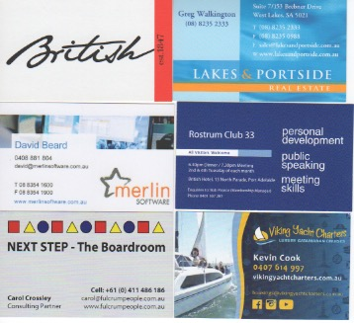



ROTARY CLUB OF PORT ADELAIDE
P.O.Box 82 Port Adelaide, South Australia 5015
Chartered 3rd July 1946
R.I. President: Barry Rassin
District Governor: David Egan

